Environment Variable

- How can you know what is the secondary command prompt set your system ?
ANSWER:
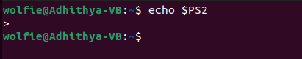

How can you change the secondary command prompt from the default to your username ?
ANSWER:
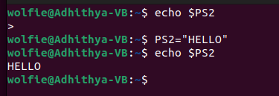

2. How can you ensure that the mv command (used for renaming a file) always asks for permission before overwriting an existing destination file ?
[ Hint : use alias command ]
ANSWER:

